Figure S1. Difference map of creative uses and nonsensical uses against common uses in the N400 time window.
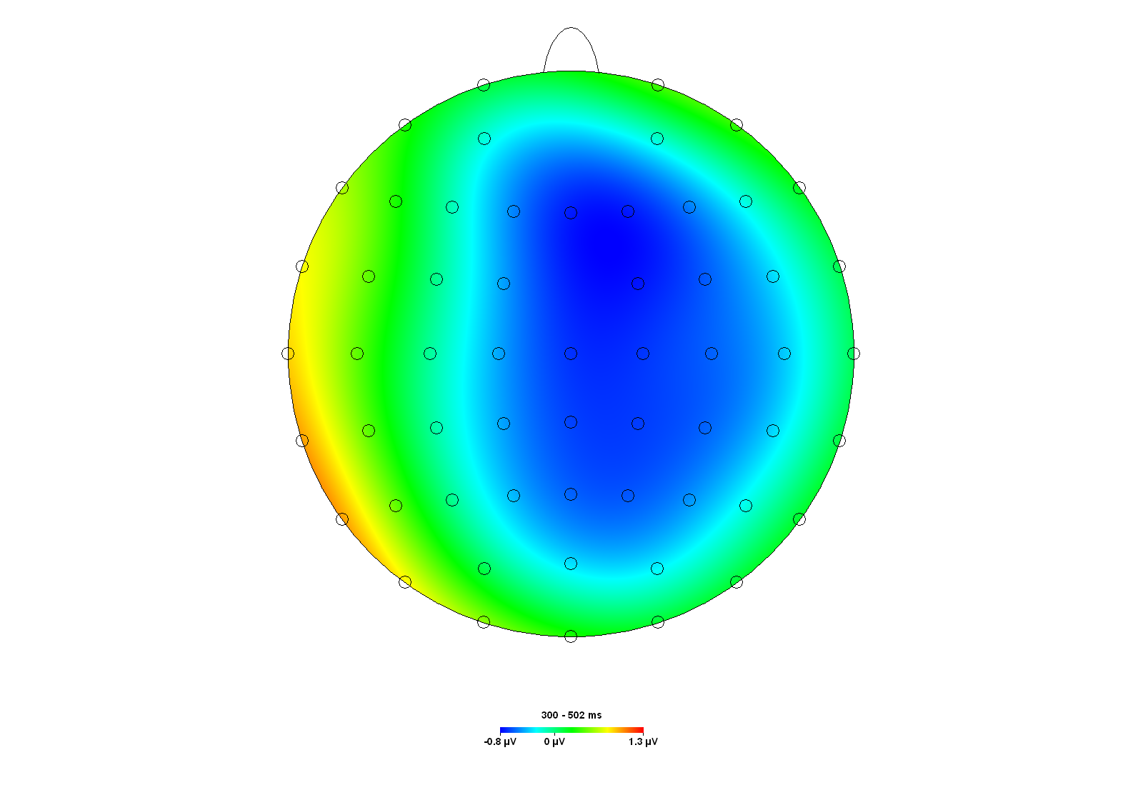

Figure S2. Difference map of nonsensical uses against creative and common uses in the post-N400 time window..

